Derailer Tuning
To enjoy riding your bicycle, it must have perfectly tuned derailers so that the speed transitions are smooth and precise. Tuning derailers is really easy and a matter of a few minutes once you get some experience doing it.
Most derailers have two Phillips screw on them so that you can set the inner and outer limits of the derailer travel zone. This must be well adjusted to avoid situations where the chain would drop off the sprocket due to a too long derailer travel.
Lets first find these screws. Look at the front derailers first. You will probably find the two screws on the top of that piece. Now look at the rear derailer. The two screws are usually located on the back of the main derailer body. The picture below points out typical locations for the screws.
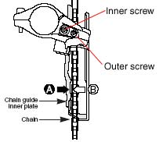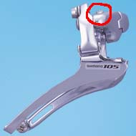
Top view of a Shimano 105 front derailer (left) taken from service instructions manual and side photo (right) (http://bike.shimano.com)
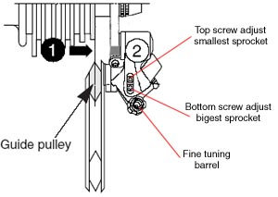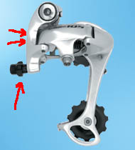
Rear view of a Shimano 105 rear derailer (left) taken from service instructions manual and side photo (right) (http://bike.shimano.com)
Now that you know where the screws are located, lets get to Work. If you are lucky enough to have a bicycle handle in your shop that is surely the easiest way to do these adjustment manipulations. Thought, as you will see, it is easy to do these adjustments without it. For both front and read derailers, the same technique will apply. Using the derailer shifter levers, make the selected derailer go one speed up or down at a time. Then, with one hand, lift the bicycle by its saddle tube. With the other hand, Turn the pedals forward until the chain is stable on the desired front and rear sprockets. Repeat this procedure until the chain is set to the correct sprockets. For each derailer, you will have to adjust the minimal and maximal derailer extension. To do that, you will have to set the chain to both its extreme positions on the left-most and right-most sprockets. Once you have done this, you will be able to turn the derailer screws and watch the the derailer guide move inward and outwards you do.
Let's begin with the inner derailers positions. Like explained above, proceed to change the chain position so that it is in the smallest front sprocket and the biggest rear sprocket. Once you are done, the chain should look like this:
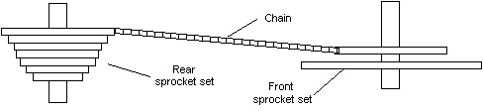
Now, use the inner derailer screw of the front derailer and turn it so that the derailer guide is touching the chain on its side inward the bicycle frame. Then turn the screw slowly until you see about two millimeters if gap between the chain and the derailer guide. Then, go to the rear derailer and adjust its inner screw so that the middle of the derailer flywheel is aligned with the middle (the teeth) of the biggest rear sprocket. By gently turning the pedals, you should notice very little gear noise. Also make sure the chain is not touching any derailer parts (especially the front derailer guide).
Now, do the exact opposite thing we just did. That is, change the chain position so that it is in the smallest rear sprocket and the biggest front sprocket. The chain should look like this:
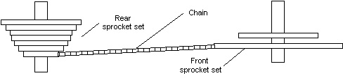
Here again, adjust the front derailer so that its guide touches the outward side of the biggest sprocket (toward the pedal). Then slowly turn the outward screw so that a two millimeter gap appears between the guide and the chain on the sprocket. For the rear derailer, adjust the outer screw so that the middle of the derailer flywheel is aligned with the middle of the smallest rear sprocket gear. Verify again that the chain is not touching any derailer parts by slowly turning the pedals.
We are almost done. No we need to finish our derailer tuning by making sure the rear derailer speed offset is correct. To do that shift the rear derailer one speed down (the chain will end up on the sprocket next to the current one, the smallest one). Verify that the middle of the derailer flywheel is again in the middle of that sprocket gear. If it is not, gently turn the fine tuning barrel clockwise or counter clock wise as you look at the derailer flywheel. When it is in the middle of the sprocket gear, turn the pedal and see how the derailer sounds. The less sound it makes means you have the best setting. Go yet one gear down and redo the whole process. Then check the sound it makes again. After a few iterations, you should pretty much end up with a close to perfectly tuned derailer. Now is time to take that bicycle and Ride it a few minutes and play with the gears thoroughly.
If the chain goes off one of the sprockets, it means you set one of the derailer screw so that it moves too much inward or outward. If that is the case, repeat the process we just went trough. If the rear gears makes weird noises (like it is about to change speed all the time), Your fine tuning barrel is not correctly adjusted. In that case, use the barrel again and make sure the derailer inter-speed offset is correct.

